Assignment by Nishan Bhandari
BCA 3rd Semester
Site map

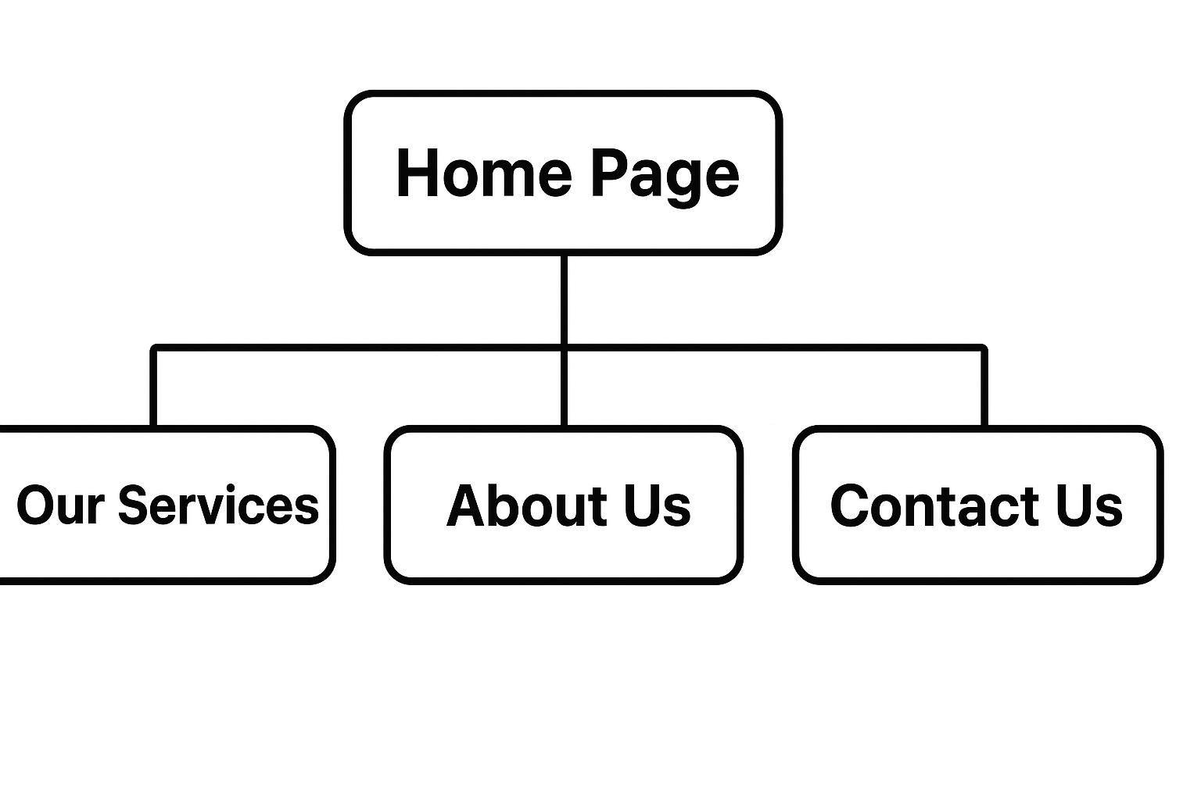
Images are downloaded from Pinterest and Google

